DML Data Manipulation Language => SELECT, INSERT, UPDATE, DELETE, MERGE;DDL Data Definition Language=> CREATE, ALTER, DROP, RENAME, TRUNCATE, COMMENT;DCL Data Control Language=> GRANT, REVOKE;Transaction Control=> COMMIT, ROLLBACK, SAVEPOINT;SQL statements are not case sensitive,Can have 1 or more lines,Clauses are usually palced on different lines,Indent for better readability,Semicolons are optional on iSQL*Plus , but required at the end of multiple statements,Semicolones are requiredon SQL*PlusConcatenate OperatorLinks ||q Operator(just like the example above)q' [, it's assigned Manager ID:]'|| manager_idAS 'Department and Manager'SELECT last_name ||;DISTINCTwill display repeated rows only 1 time, removing;Duplicated rowsDESCRIBEtablename*will display table structure completelyWHERE last_name= "Whelan" WHERE department_id = 90 The default Date format is DD-MON-RR WHERE hire_date = '17-FEB-96'DEFINE employee_num = 200 SELECT …..FROM ……WHERE employee_id = &employee_num UNDEFINE employee_num% => denotes zero or many characters _ => denotes one characterAND OR NOT WHERE salary >= 10000 AND job_id LIKE '%MAN%' WHERE salary >= 10000 OR job_id LIKE '%MAN%' NOT 'IT_PROG','ST_CLERK') WHERE job_id LIKE '%_%' In order to escape _ We do WHERE job_id LIKE '%\_%' ESCAPE '\'

There are two types of functions Single-row functions one result per rowMultiple-row functions one result per group of rows Functions **LOWERLowercaseUPPERUppercaseINITCAPCapitalizeSUBSTRCut string**SUBSTR('Hello World', 1 , 5) => Hello ;CONCATJoin together CONCAT('Hello','World') => HelloWorld ;INSTRCharacter positions ;INSTR('Hello', 'e') => 2

LPAD RPAD LPAD(salary,10,'*') => *****24000 REPLACE Replace values REPLACE('JACK','J','R') => RACK TRIM Remove whitespace or characters TRIM ('H' FROM 'HelloWorld') => elloWorld ROUND(45.926 , 2 ) => 45.93;TRUNC(45.926 , 2 ) => 45.92;MOD(1600, 300) => 100 ;SELECT SYSDATE FROM DUAL ; 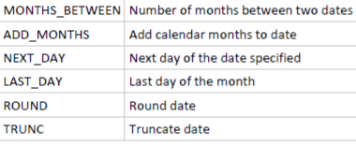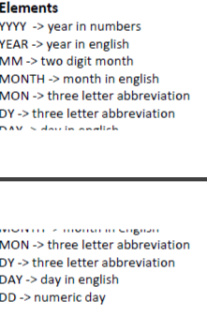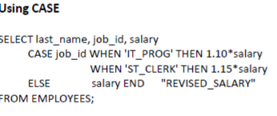

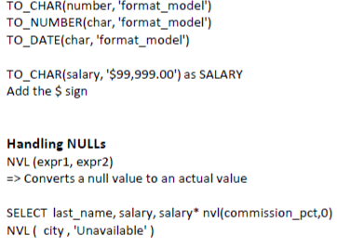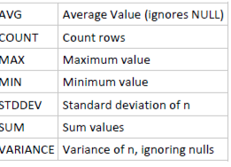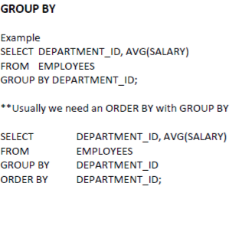

Example:SELECT department_id, MAX(salary) FROM employees GROUP BY department_id HAVING MAX(salary)>10000;

CREATE VIEW view_name AS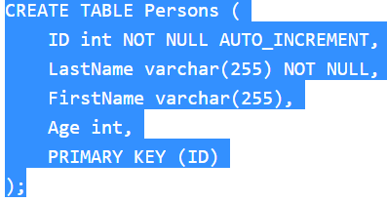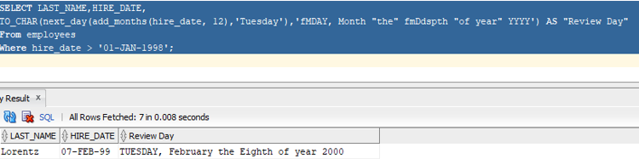  
SELECT column1, column2, ...  
FROM table_name  
WHERE condition;

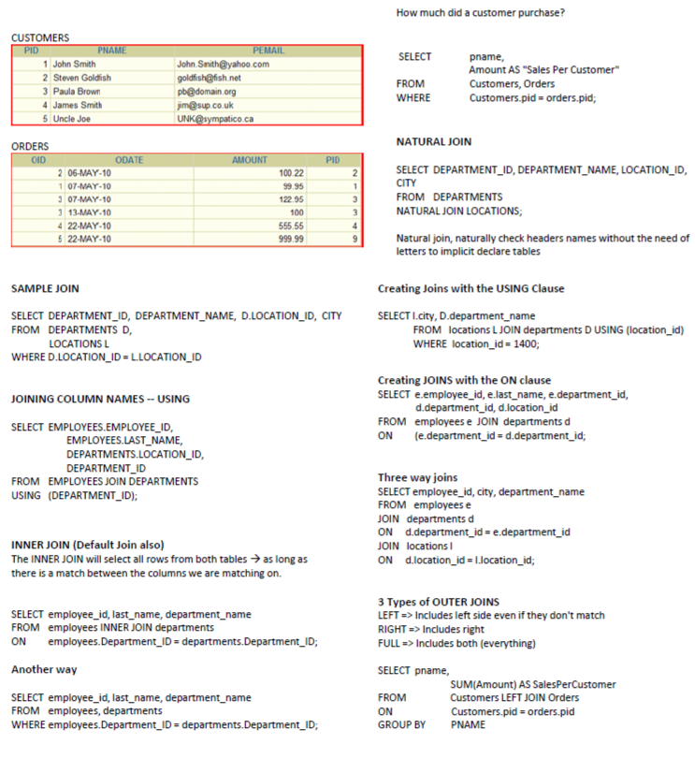

**SELECT e.last_name emp,**

**m.last_name mgr**

**FROM employees e JOIN employees m**

**ON (e.manager_id = m.employee_id)**

**WHERE e.last_name like 'Lorentz';**

SELECT Orders.OrderID, Customers.CustomerName, Shippers.ShipperName  
FROM ((Orders  
INNER JOIN Customers ON Orders.CustomerID = Customers.CustomerID)  
INNER JOIN Shippers ON Orders.ShipperID = Shippers.ShipperID);

